**I2c interview:**

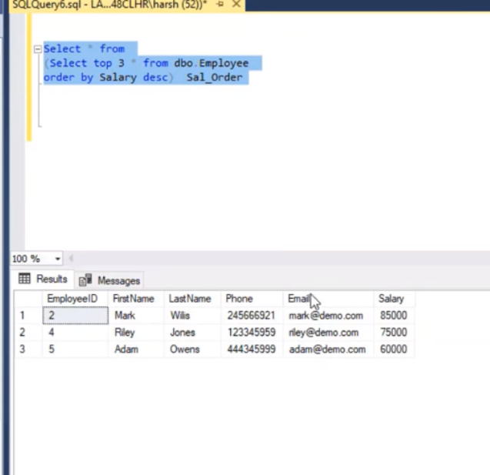

select * from system.personal where salary=(select max(salary) from personal);

select * from system.personal;

--list of second

select * from system.personal where salary<(select max(salary) from personal);

select * from system.personal;

--Second employee salary

select * from system.personal where salary<(select max(salary) from personal) order by salary desc;

--second highest salary of the table

select max(salary) from system.personal where salary<(select max(salary) from system.personal)

--how to get top 1 highest salary

select top 1 * from system.personal order by salary desc;

--select top 3 highest salary

select top 3 * from system.personal order by salary desc ;

select * from

(select top 3 * from system.personal order by salary desc ) sal_order

